**Question # 3 [2.5 marks]**

The region bounded by the curve , the x- and y-axes, and the line x = 10 is rotated about the x-axis. Use Trapezoidal Rule with n = 10 to estimate the volume of the resulting solid.

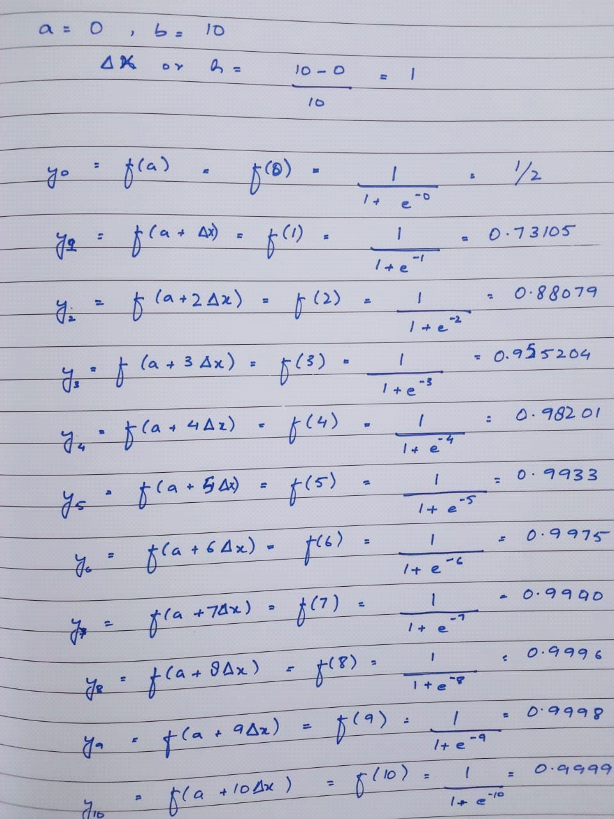

Formula:

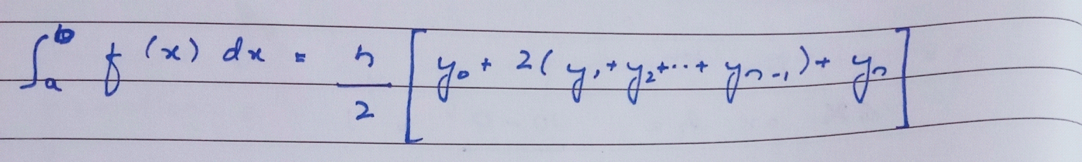

Calculation:

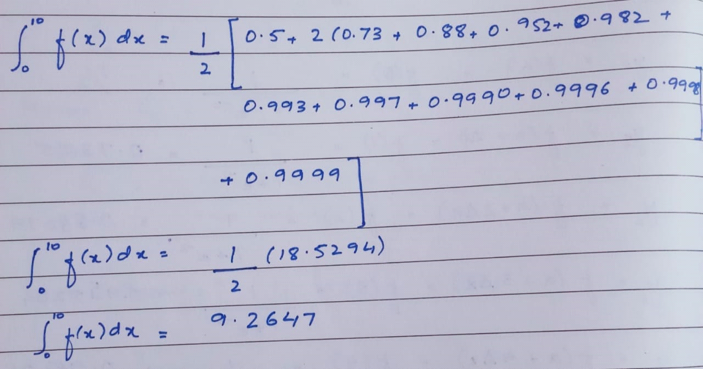

**Question # 4 [2.5 marks]**

A robotic arm with a rapid laser scanner is doing a quick quality check on holes drilled in a rectangular plate. The centers of the holes in the plate describe the path the arm needs to take, and the hole centers are located on a Cartesian coordinate system (with the origin at the bottom left corner of the plate) given by the specifications in Figure 1.

If the laser is traversing from x=2 to x= 4.25 in a linear path, what is the value of at x= 4.00 using the Lagrangian method?

